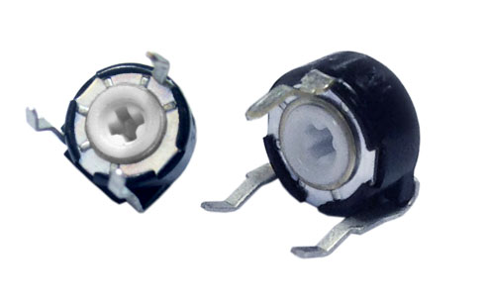**Piher Sensors & Controls S. A.**

**PIHER’s New Miniaturized Trimmer Offers Rotary Click Sensation**

PIHER Sensors and Controls S.A. has re-designed its popular PT-6 Carbon Potentiometer to include detents, providing users desirable tactile feedback on each position setting and selection.

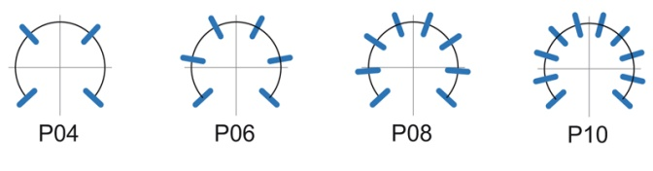The new detents, which include up to 10 equally spaced positions, have a spring feature that is incorporated into the product’s rotary action. This creates a resistance to rotation at predetermined angles that gives the user a ‘click’ action, alerting the user of the current position of the control. For maximum design versatility, the detents can be set at custom angles to suit specific requirements.

The PT-6 Potentiometer, already popular in hundreds of white goods, motor control, power supply, appliance panel control, and automotive sensing applications, now offers product designers the full features of PIHER larger products in a miniature 6mm control / trimmer package.

***Standard Detent Configurations***

* Relative detent positions along the total mechanical travel. Unless otherwise specified, the detents are evenly spaced (using the end points as reference). For versions with more than 10 detents, contact PIHER.*

The 6 mm family features flame-retardant plastics (meets UL Standard 94 V0) for the SMD version, a carbon resistive element, dust and water proof enclosure (IP54). The new pot is supplied in magazines for easy automatic insertion and is available with a variety of options including crimped terminals, standard knob and shafts and ganged versions.