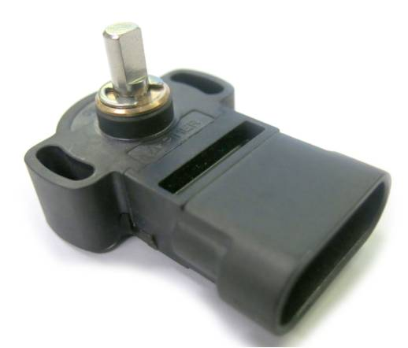

**PIHER Introduces Second Generation 360° Position Sensor**

**Featuring Easy Plug-N-Play Design**

PIHER Sensors and Controls S.A. has introduced the second generation non-contacting PSC-360 Hall effect rotary position sensor featuring an integral six-pin mating connector that features all the inherent advantages of the original proven model. The new PSC-360 IC magnetic sensor package eliminates the need for wire harnesses and separate mating connector, making it easier than ever - engineers simply plug the sensor into their product.

This integral connector version uses the popular Delphi Metripack 150.2 series (12162210/12162260 /12162261). Using triple-rib peripheral silicone rubber seals, the PSC-360 IC family is ideally suited for exceeding the environmental requirements in most off-highway, industrial, marine, agriculture and heavy equipment applications. Additionally, the PSC-360 IC Sensor offers high temperature capabilities with operational performance between -40ºC to +125ºC and high accuracy over 360º with as little as 0.5% linearity error.

The technology used by Piher breaks through the traditional magnetic fluctuation and complex circuitry barriers. Piher’s technology is only sensitive to the flux density coplanar with the IC surface, which eliminates those problems and optimizes accuracy for absolute position feedback from 0 to 360 degrees. The simple, low-cost package maintains a true non-contacting air gap between the rotating magnet and the fixed sensing system.

Designed with the permanent magnet as the only moving component, the PSC-360 IC sensor provides a mechanical life of up to 50 million cycles. Further durability is incorporated with the fully sealed magnet and the sensor’s electronics (sensing system) encapsulated in molded plastic, providing a completely sealed IP67 rated sensor that is totally impervious to humidity. These features are ideally suited to harsh environmental exposure where shock, vibration, high humidity and dust are unavoidable.

Piher’s technology is not only true absolute - maintaining the sensor’s true position even after a power interruption, it also offers redundancy achieved with a dual core version within the same housing. The result is a highly configurable sensor that offers an excellent solution for the severe conditions found in industrial equipment, food processing, agriculture, off-highway, precision robotics, and HVAC monitoring and control applications. Specific uses include hand throttle control and throttle position feedback, accelerator and brake pedals, wheel angle for off highway vehicles and tractors, farm implement position feedback, forklift lift and tilt control, suspension height, marine, cranes and airport ground support vehicles.

**PIHER Introduces New Rotor Version of**

**PST-360 Through-Shaft Sensor**

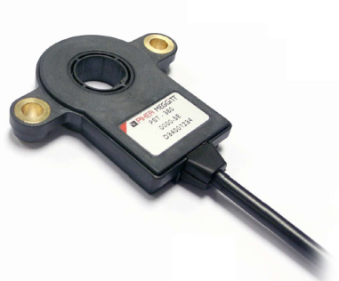

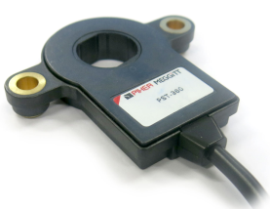

*The PST-360 Hall effect Rotary Position Sensor Family now includes both 14 mm diameter (left) and 17mm rotor diameter (right) versions.*

PIHER Sensors and Controls S.A. has introduced the second version non-contacting PST-360 Hall effect rotary position sensor in a **17mm** rotor diameter, featuring all the inherent advantages of the current **14mm** proven model. The new device allows designers even more choices for selecting the right contactless sensor to meet the specific customer shaft design-in application..

Engineers designing rugged vehicles want all the benefits of contactless rotary sensing (no wear and tear) without expensive, over-engineered positioning solutions. Enough accuracy plus stable performance that stands up to environmental extremes over a long lifetime are also important considerations.

Contactless Hall effect specialist Piher Sensors & Controls has just launched this new version that directly fulfills these demanding requirements. Piher’s novel ‘through shaft’ sensor effectively wraps around any shaft sensing directly at the source. One slimline 9mm package contains two non-contacting components – a full circle magnet and an electronics module. The application-patented design can be fitted anywhere on a shaft, giving engineers the flexibility to be creative. It is easy to assemble, so production line costs are less than that of other sensor solutions. For operators, it’s about maintenance – none is needed over the product’s lifetime.

Piher’s technology is not only true absolute - maintaining the sensor’s true position even after a power interruption, it also offers redundancy achieved with a dual core version within the same housing. The result is a highly configurable sensor that offers an excellent solution for the severe conditions found in industrial equipment, agriculture, construction, off-highway, precision robotics and control applications. Specific uses include hand throttle control and throttle position feedback, accelerator and brake pedals, wheel angle for off highway vehicles and tractors, farm implement position feedback, forklift lift and tilt control, suspension height, marine, cranes and airport ground support vehicles